Steps to configure gardle in local system

1. Download and install gradle
   1. Download latest gradle binary from <https://gradle.org/next-steps/?version=8.6&format=bin>
   2. Create a folder C:/gradle
   3. Extract the downloaded binary from step (a) and place under folder C:/gradle

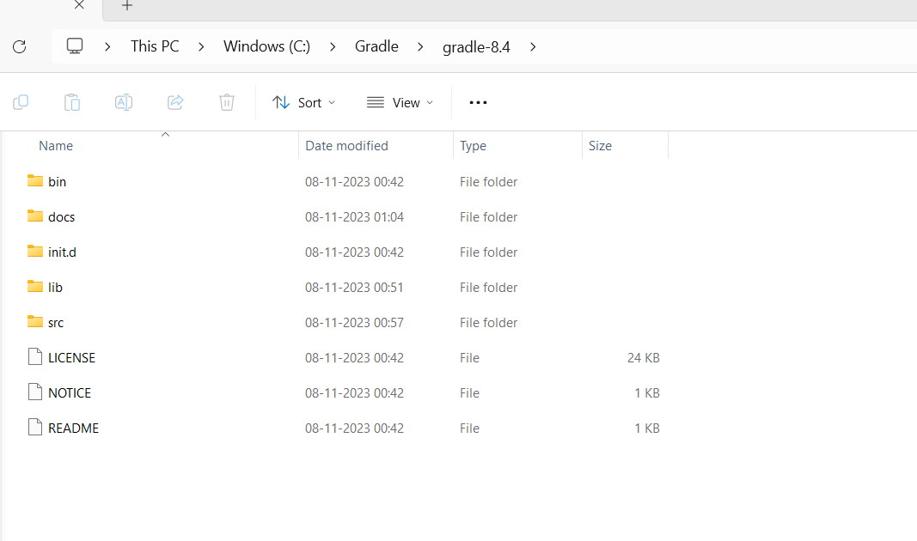

* 1. Configure environment variables to set the path for gradle

Click on This PC (or Computer) icon, then click Properties -> Advanced System Settings -> Environmental Variables.

Under System Variables select Path, then click Edit. Add an entry for C:\Gradle\gradle-8.6\bin. Click OK to save.

1. now go to command prompt and type c:\gradle -v

we should get gardle version on console.

1. TTo setup gradle build, please follow below steps

1. create a folder to setup project and goto command prompt and type below command

C:/gradle init

Select type of project to generate:

1: basic

2: application

3: library

4: Gradle plugin

Enter selection (default: basic) [1..4] 2

Select implementation language:

1: C++

2: Groovy

3: Java

4: Kotlin

5: Scala

6: Swift

Enter selection (default: Java) [1..6] 3

Generate multiple subprojects for application? (default: no) [yes, no] no

Select build script DSL:

1: Kotlin

2: Groovy

Enter selection (default: Kotlin) [1..2] 2

Select test framework:

1: JUnit 4

2: TestNG

3: Spock

4: JUnit Jupiter

Enter selection (default: JUnit Jupiter) [1..4] 2

Project name (default: Selenium_Udbita):

Enter target version of Java (min. 7) (default: 17): 17

Generate build using new APIs and behavior (some features may change in the next minor release)? (default: no) [yes, no] no

> Task :init

To learn more about Gradle by exploring our Samples at https://docs.gradle.org/8.6/samples/sample_building_java_applications.html

BUILD SUCCESSFUL in 57s

1 actionable task: 1 executed

1. After successful gradle project creation copy the project dir from git to your local folder

Goto app folder

And run gradle –refresh-dependencies

It will download all binaries

1. To test your testing xml gradle test